Still Life Photography Read Along  Name: | 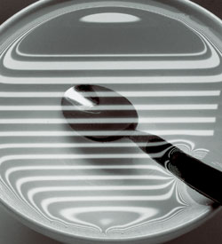

1) Throughout the decades, artists have depicted still life scenes--______________ _____ ______________ ___________--in paintings and photography.

2) Good ______________, _____________ and __________ are all very important to translate your still life into a great photo.

3) Notice how photographers use repeating _______________ and ____________ to create patterns and use _____________________ colors

4) One of the best things you can do before you shoot still lifes is to collect images that ____________ you.

5) Instead, choose a few objects with a _______________ _____________.

6) Experiment with your _______________ ___________ until the scene shows the elements in the most pleasing balance.

7) Photograph the original grouping, and then __________________ or _____________ objects to see if it improves the composition.

8) You can also create a good still life with some of your own _________________ ______________.

9) This self-assignment can be an experiment in light, shape, color, and composition, as well as an opportunity to express your own _____________________.

10) You'll get much more _______________ light than with the __________ illumination that on-camera flash provides

Four Tips In Brief (Rewrite the four tips in brief below)
- Collect still life images that you ____________.
· Assemble ____________ objects to create a unique still life statement.
· Keep compositions _______________.
· Utilize _____________ elements and _____________ to produce strong still life photos.

