Video Production
Sound Read-Along
http://video101course.com/sound.html

- There is a natural tendency to place the handheld too ____________--but you should place it fairly _____________ to the mouth (but NOT blocking the ___________)

- Both ___________________ and _________________mikes are supercardioid mikes that are pointed at the subject from a _________________--and thus _________________ to the TV viewer.

- The big ______________of booms and fishpoles is that you need a ______________ ______________to hold the darn thing.

- The trick to using a fishpole or boom is to remember that they should always be pointed at the subject and ______________up or down--never ______________.

- A wireless mike is--in essence--a very low power ______________radio station.

- wireless mikes ______________with distance

- the wireless mike signal can also be ______________by random ______________noise.

- Perhaps the biggest downfall is that good wireless ______________are very expensive.

- Our program owns two, and has ordered 3 more, Sony –UWP-VS wireless microphones. Do an internet search and figure out how much those microphones cost. ____________________

- So anytime you want to hear something that's ______________ ______________ ______________, a ______________mike might be in order.

- Nearly every professional recording device--including pro ______________, --has a ______________, of some sort to increase or decrease the ______________, of the audio being recorded.

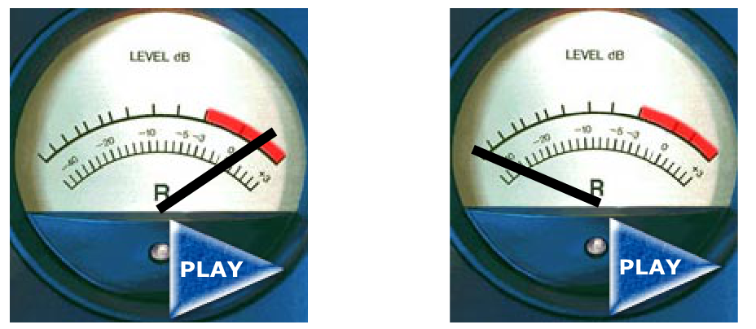
- Click the “Play” button on these two recordings and rewrite below what he says in the recording:
  - Answer for too high:
  - Answer for too low:

- What does “Automatic Gain Control” do to your audio when there are pauses during the speaker?
  - ____________

- As a result, professionals ______________ use the automatic gain control.

- The bottom line is that it is ______________ to use automatic gain when you are ______________ --with the understanding that at some point, you'll need to give it up and learn to control levels ______________.

- At any given point in time, only _______________ audio source can be dominant.
- In a given piece, the _______________ audio source might change several times.

- if you plug a microphone into a _______________ input, it won't work--the sound signal will be to _______________. Similarly, if you plug _______________ audio into a mike input, it will create horribly _______________ audio.

- Rewrite the three advantages of XLR connectors in your own words
  - Here
  - Here
  - Here

- The advantage of the "mini" connector is that it is, well, _______________.

- Rewrite Rule #1 on pg 31 (look at the url at the top) in your own words.

- Rewrite Rule #2 on pg 32 (look at the url at the top) in your own words.

- "Natural sound" is all the audio that is NOT people _______________.

- Natural sound--even if it very _______________.--is important to creating a feeling of _______________.

