Video Production
Sound Read-Along
http://video101course.com/sound.html

- Many students are surprised to learn that it is not ______________ for a television production company to spend more time working on the _______________ portion of a TV program than the __________ portion

- What example does the author give to help you imagine what sound waves are like (1-2 sentences)

- If the waves are hitting in _____________ succession, your brain interprets this as a __________ pitched sound (wind chimes, for example).

- If the waves hit your eardrum ____________ rapidly, your brain interprets this as a ___________-pitched sound

- Anyone who listens to music that loud for a long time WILL develop hearing loss around age _____________.

- That's because women's voices are somewhat ____________________ in frequency--in the ranges that your great grandma has lost.

- women's voices are somewhat ________________ in frequency

- An ____________________ pickup pattern means the mike picks up sound evenly in all directions.

- Are omnidirectional microphones commonly used? (Why or why not?) (1-2 sentences)

- _______________ (pronounced "CAR-dee-oid") mikes pick up sound in one direction only.

- ________________ (Sometimes called "hypercardioid") mikes are very directional--even more so than a cardioid.

- Supercardioid mikes are more commonly known as _______________ mikes.

- 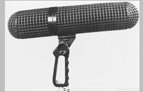 What is this a picture of _____________________________

- What is the difference between a dynamic and condenser microphone? (2-5 sentences, DO NOT copy and paste)

- ______________ microphones are the tiny mikes that can be clipped onto clothing.

- Of the two mentioned which do you think is the most useful advantage (and why) of lavalier mics for our types of productions

- Of the two disadvantages of lavalier mics which do you think is the biggest problem for us? (2-3 sentences)

- 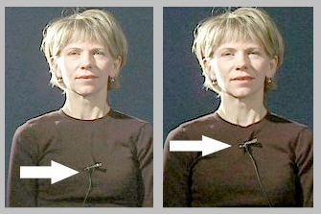 which is correct (left or right) and why?

- Handhelds--known in the business as _______________ mikes--have a big advantage in that they are __________ to ___________ around at a moment's notice.

- Summarize the two problems of a stick mic (2-3 sentences each)

